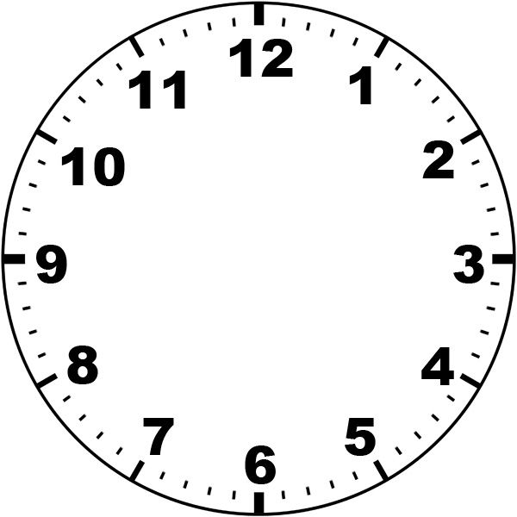

**Classroom Activity Clock**

Use this clock alongside your classroom wall clock to help indicate to children when an activity/ lesson will start and finish. This will especially hep children who find it difficult to concentrate for periods of time and children who need their day to be more structured such as children with autism, ADHD.

Cut out the clock face and hands. Use a paper fastener to attach the hands so they can move around.